COMPUTER SCIENCE DEPARTMENT

CS0019
Modeling and Simulation

TECHNICAL ASSESSMENT
1

Introduction to MATLAB

Student Name: | Jecyn Vallirie M. Turbanos
Section: | TN36
Professor: | Jericho Menguito

IT0123 - IT SPECIALIZATION 7: DEVELOPMENT NETWORK
DevNet Resource Validation
Use AI to recommend a DevNet resource, verify it against official Cisco documentation, and record the plan in Git.
MODULE  2 | DURATION  90 minutes | MODE  Individual or Pair | CHECKS  9

Core rule
An AI recommendation is provisional. Accept it only after an official Cisco source supports the resource type, access model, and intended use case.

1. Overview
You are preparing a development-environment plan for four fictional network-automation tasks. For each task, you will ask an approved AI tool to recommend one DevNet resource category, independently verify the recommendation using official Cisco documentation, complete a structured JSON plan, run an offline validator, and preserve the evidence in a local Git repository.

2. Learning outcomes
- Explain the roles of DevNet Learning Labs, DevNet Sandbox, and Cisco Code Exchange.
- Differentiate Always-On and Reservation Sandboxes based on access, isolation, setup, and administrative privileges.
- Select and justify an appropriate DevNet resource for a stated development or automation need.
- Validate AI-generated claims using official technical documentation.
- Use Git to preserve a reproducible resource-selection and validation record.

3. Required tools and files
Item | Requirement
Browser | Access only official Cisco DevNet pages for evidence
AI tool | Instructor-approved generative AI assistant
Python | Python 3.10 or later; no third-party packages
Version control | Git installed locally; GitHub publishing only when instructed
Starter files | devnet_use_cases.json, student_plan_template.json, validate_plan.py, README_template.md

4. Safety, ethics, and account protection
Read-only exploration by default
Do not create a reservation, connect a VPN, run API requests, or change a sandbox unless the instructor explicitly authorizes it. Never paste usernames, passwords, API keys, tokens, reservation emails, private repository content, or personal data into an AI tool.

- Use only fictional use cases supplied with the activity.
- Official evidence must come from developer.cisco.com.
- Record whether each AI recommendation was verified, partially verified, or rejected.
- A correct selection without evidence and AI disclosure is incomplete.

5. Resource decision guide
Resource | Use when | Important constraint
Learning Lab | Guided, step-by-step learning is the main need | Learning content; not a substitute for choosing an execution environment
Always-On Sandbox | Immediate shared access and non-admin API exploration are sufficient | Shared environment with restricted administrative access
Reservation Sandbox | Private access, administrative control, or configuration testing is required | Reservation, setup time, and often VPN access are required
Cisco Code Exchange | Existing code repositories or automation examples are needed | Code must still be reviewed, tested, and matched to the use case

6. Official evidence sources
- DevNet Sandbox documentation: https://developer.cisco.com/docs/sandbox/
- DevNet Learning Labs: https://developer.cisco.com/learning/
- Cisco Code Exchange: https://developer.cisco.com/codeexchange/
Terminology update
Cisco states that Automation Exchange has been consolidated with Code Exchange. Use Cisco Code Exchange in the revised syllabus and student outputs.

7. Procedure
- Prepare the workspace: Create a folder named it0123-devnet-resource-plan and place all starter files inside it.
- Initialize Git: Run git init, add README_template.md as README.md, and create an initial commit with a meaningful message.
- Inspect the scenarios: Open devnet_use_cases.json. Identify the decisive requirement in each use case before consulting AI.
- Prompt AI: Ask the AI to recommend one of four resource types: learning-lab, always-on-sandbox, reservation-sandbox, or code-exchange. Require a reason and a claim that can be verified.
- Verify independently: Open the relevant official Cisco page. Check the AI claim against the resource description, access model, and intended use.
- Complete the plan: Copy student_plan_template.json as student_plan.json. Fill every field using the exact resource labels required by the validator.
- Run validation: Execute python validate_plan.py. Correct the plan until the validator reports 9/9 checks passed.
- Complete the README: Summarize the decisions, official evidence, AI evaluation, validator result, and AI-use disclosure.
- Commit the evidence: Add the completed JSON, README, and a text copy or screenshot of the validator result. Commit with a message that describes the validation milestone.
- Prepare for oral checking: Be ready to defend one resource decision and explain why an alternative resource was less suitable.

8. Suggested AI prompt
I am selecting a Cisco DevNet resource for a fictional classroom use case.
Use case: [paste one scenario]
Choose exactly one: learning-lab, always-on-sandbox,
reservation-sandbox, or code-exchange.
Explain which requirement drove your choice. State any access, isolation,
setup, or privilege claim that I should verify in official Cisco documentation.
Do not invent a sandbox product name, URL, account, or credential.

9. Required labels
learning-lab
always-on-sandbox
reservation-sandbox
code-exchange
Verification status: verified | partially-verified | rejected

10. Evidence and deliverables
- student_plan.json with all four validated resource decisions
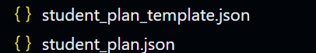
- README.md with official sources, Git evidence, and AI-use disclosure
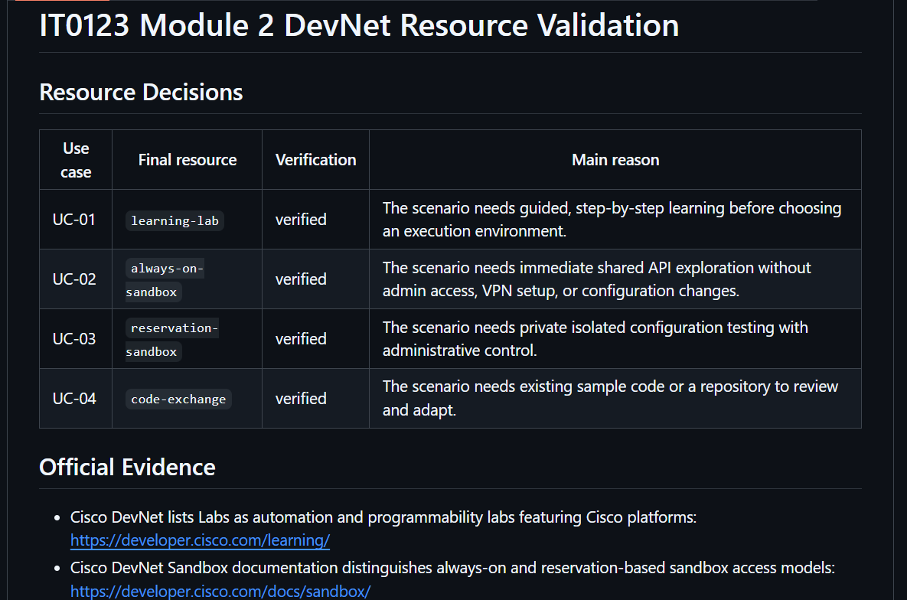
- validator output showing 9/9 checks passed
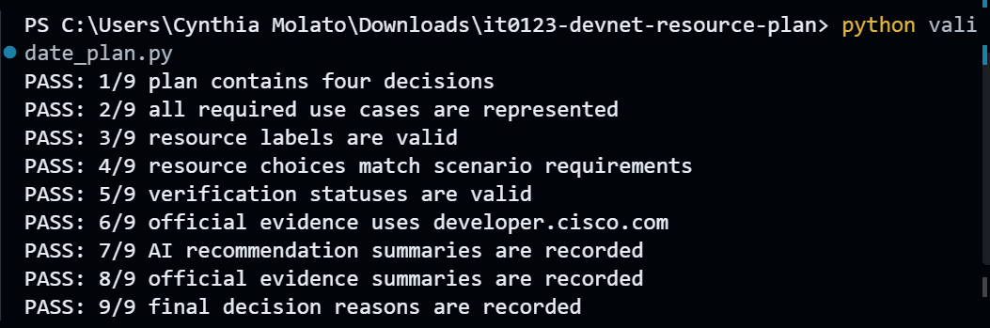
- local Git repository with at least two meaningful commits
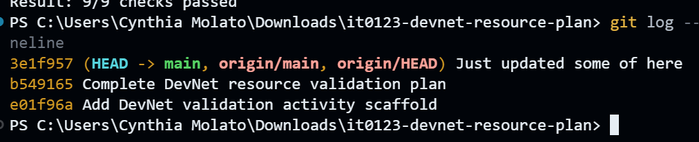
- AI prompt record or transcript excerpt for each scenario
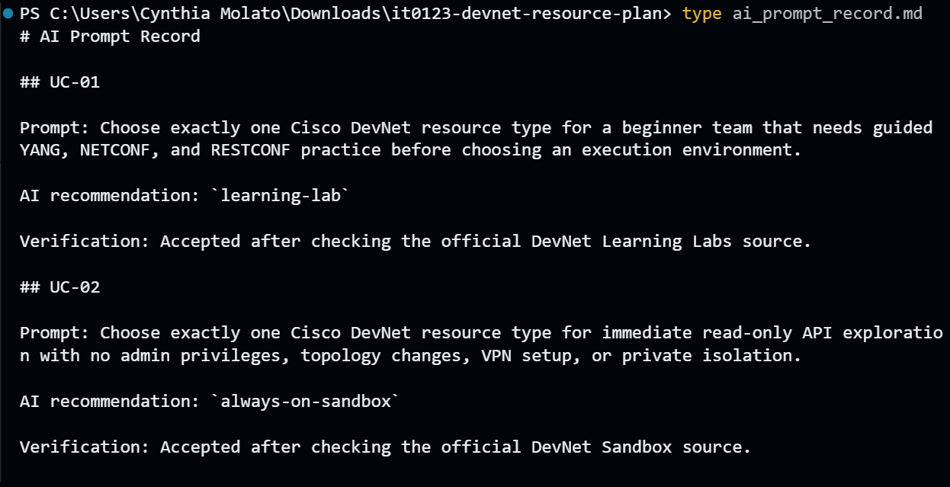
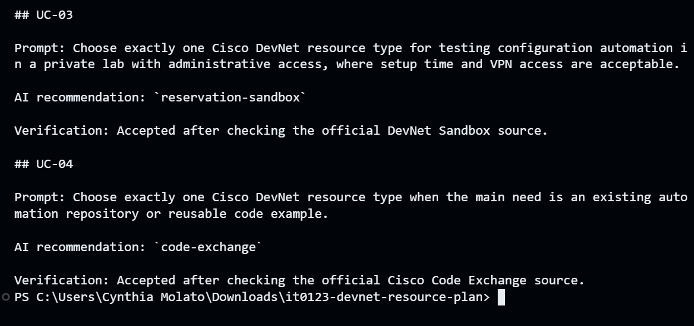
- Optional instructor-approved GitHub repository link
https://github.com/Vallywi/it0123-devnet-resource-plan
Github Repository: https://github.com/Vallywi/it0123-devnet-resource-plan.git

11. Reflection questions
1. Which scenario was easiest to classify, and which requirement determined your choice?
UC-04 was the easiest to classify because it clearly needed an existing automation example or reusable code repository. That requirement directly matched Cisco Code Exchange, since Code Exchange is used for finding sample solutions and implementations.
2. Describe one AI claim that needed correction, qualification, or rejection.
One AI claim that needed qualification was that an Always-On Sandbox is best for API tasks. I verified that it is useful for quick shared access, but it is not suitable for every case, especially when the task requires private isolation, administrative control, VPN access, or configuration changes.
3. Why is an Always-On Sandbox not automatically the best option for every API task?
An Always-On Sandbox is not automatically the best option because it is shared and usually limited. It works well for quick API exploration, but API tasks that need private access, administrative privileges, or configuration testing are better suited for a Reservation Sandbox.
4. How did Git improve the traceability of your resource-selection process?
Git improved traceability by recording the activity progress through commits. It showed when the activity scaffold was created and when the completed validation plan was added, making the resource-selection process easier to review and verify.

12. Assessment rubric
Criterion | Points | Evidence
Resource classification | 25 | Four selections match the scenario requirements
Official evidence validation | 25 | Accurate Cisco sources and defensible verification
AI evaluation | 20 | Recommendations summarized and critically accepted, modified, or rejected
Plan and Git workflow | 20 | Complete JSON/README, passing validator, meaningful commits
Ethics and professionalism | 10 | No credentials exposed; clear and complete submission
TOTAL | 100

Submission filename: Surname_FirstName_IT0123_M2_DevNetPlan.zip

